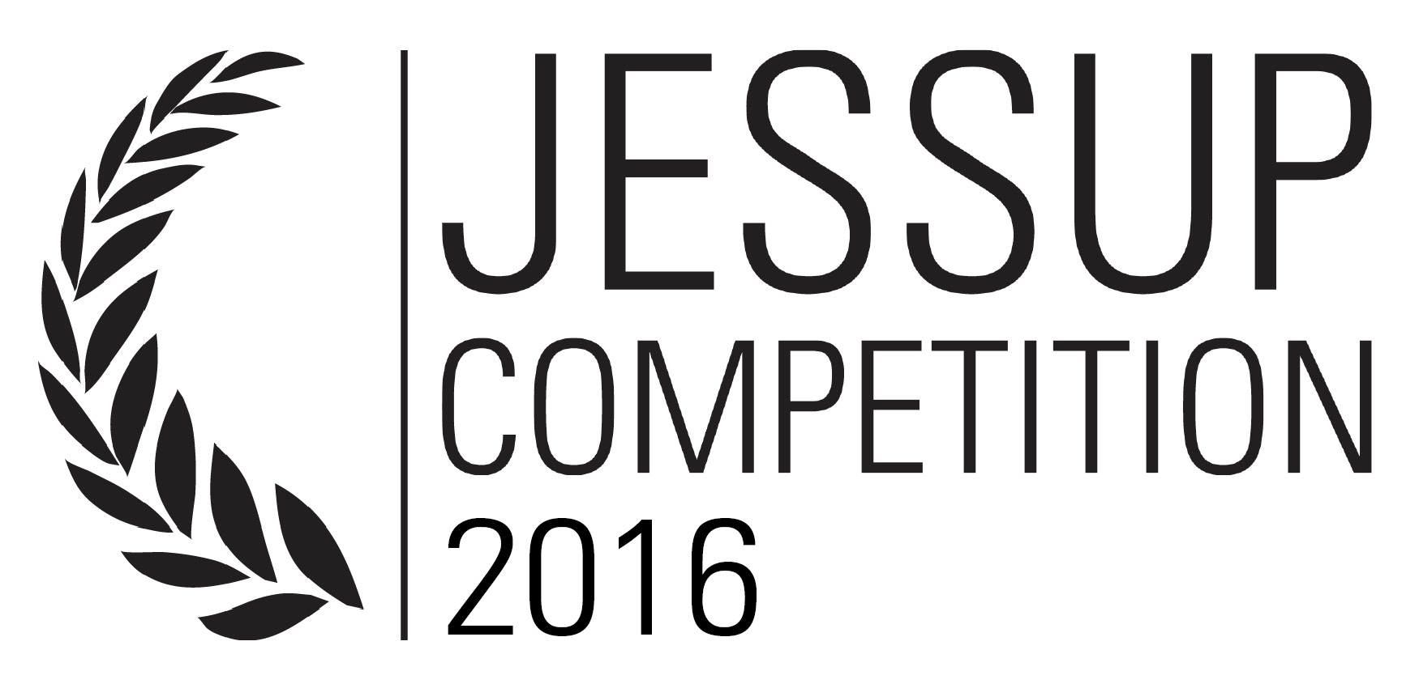
PHILIP C. JESSUP INTERNATIONAL MOOT COURT COMPETITION INDONESIAN NATIONAL RULES SUPPLEMENT
2015-2016

The Indonesian National Rules Supplement to the Official Rules of the 2016 Philip C. Jessup International Moot Court Competition (“Indonesian National Rules Supplement”) has been promulgated by the Indonesian National Administrator (“Administrator”) with the approval of the Executive Director of the International Law Students Association (“Executive Director”).
The present Indonesian National Rules Supplement is intended to facilitate the conduct of the 2016 Indonesian National Rounds of Phillip C. Jessup International Moot Court Competition (“2016 Indonesian National Rounds”).
Except as amended by this Indonesian National Rules Supplement, and its further amendment, if any, the Official Rules for the 2016 Philip C. Jessup International Moot Court Competition (“Official Rules”) shall remain in full force.
The Indonesian National Rules Supplement shall not preclude the Administrator from adopting any additional measure before, during, and after the 2016 Indonesian National Rounds, pursuant to Section 1.6 of the Official Rules.

1.2 Structure of the Competition
(b) Executive Director has the right to determine the number of Teams participating in the 2016 International Rounds of Phillip C. Jessup Moot Court Competition in Washington DC (“International Rounds”). The Indonesia's National Representative to the International Rounds shall be the Champion of the 2016 Indonesian National Rounds. However, Subject to the Executive Director’s discrection after the Indonesian National Rounds has been conducted, the Runner-Up and/ or more teams might also be invited to the International Rounds as a Competitior.

1.4. Administration of the Indonesian National Rounds
The Indonesian National Rounds is administered by the Administrator, as appointed by the Indonesian Society of the International Law (“ISIL”) and approved by the International Law Students Association (“ILSA”):
Ms. Tanita Dhiyaan Rahmani
Komplek Batan Indah Blok E No. 22, Kecamatan Setu, Serpong
Kota Tangerang Selatan 1513
E-mail: jessup.indonesia.na@gmail.com

1.7 Interpretation of the Indonesian National Rules Supplement
This Indonesian National Rules Supplement, and its further amendment(s), is to be interpreted consistently with all parts of the Official Rules. Should any question arise as to the interpretation of the Indonesian National Supplement, such questions shall be addressed to the Administrator, pursuant to Section 1.7 of the Official Rules.

2.13 Practice Rounds
(d) Every team in this competition is not allowed to conduct simulations, practice, or discussion, with any individuals who have confirmed their participation to serve as Judge in the Competition. Violation of this rule will result in the forfeit of all of the Round Points in all Preliminary Rounds that the Team competes in.
(e) Every team in this competition is not allowed to conduct simulations, practice, or discussion, with any individuals serving as Steering Committee and/ or Committee in the Competition, after Bench Memo is delivered, or, if the delivery of Bench Memo is unknown, after the memorials deadline. Violation of this rule will result in the forfeit of all of the Round Points in all Preliminary Rounds that the Team competes in.

6.1 Submission of Memorials (amending the current Section 6.1 of the Official Rules)
(a) Each team participating in the Competition must prepare one (1) Applicant and one (1) Respondent Memorial.
(b) For the purpose of scoring and judging the 2016 Indonesian National Rounds, each team must submit:
1. one (1) electronic copy of Applicant Memorial and one (1) electronic copy of the Respondent Memorial in a single e-mail addressed to ILSA Executive Director via the ILSA Homepage and Administrator via the email address set forth in Section 1.4 of this Indonesian National Rules Supplement, with both Applicant and Respondent Memorials attached as separate files titled “###A” and “###R”, respectively, where “###” is the Team’s official Team Number assigned in accordance with Rule 3.5. If one of the Memorials will be submitted late, a team may separately send the timely Memorial before the deadline without penalty;
2. fourteen (14) hard copies of Applicant Memorial and fourteen (14) hard copies of Respondent Memorial to the National Administrator at the address set out in Section 1.4 of this Indonesian National Rules Supplement no later than 27 December 2015, 11:59 PM (Western Indonesian Time/WIB). Submission via post of the hard copies must be postmarked by December 27, 2015 and proof of post should be submitted to the Participant Division email address at jessup.indonesia.participants@gmail.com;

(c) Hard copies of the memorials must be printed on both sides of the paper, with different cover colors for Applicant and Respondent, and bonded with black isolation tape.
(d) All electronic and hard copy versions of the memorials submitted to ILSA Executive Director and the National Administrator must be identical. Any discrepancy, considered by the Administrator to be an alteration, shall be penalized under Section 6.1(d) and 11.1 of the Official Rules.
(e) Once memorials have been submitted to ILSA Executive Director, whether or not the memorial deadline has expired, resubmitted memorials will be subject to a five (5) points penalty. If resubmitted after the memorial deadline has expired, resubmitted memorials will also be subject to applicable late penalties.
(f) Equipment failure or problems will not be considered a justifiable excuse for improper formatting or late submission of memorials.

6.3 Memorials Submitted in Language Other than English
(a) Unless approved by the Executive Director and the National Administrator in written consent, Memorials in languages other than English will not be accepted.

7.13 Scouting (amending the current Section 7.13 of the Official Rules)
(a) Team Members or persons directly affiliated with any Team may only attend Preliminary Rounds in which their Team is competing. Violation of this Rule will be regarded as a Scouting and should be brought to the attention of the bailiff and/or Administrator immediately, without disturbing the Oral Round, or immediately after the Oral Round has finished.
(b) Team Members shall include all registered members of a Team, regardless being an Oralist or not while persons directly affiliated with any Team shall include coach(es) and advisor(s) of the said Team.
(b) There are two types of scouting, both of which are prohibited. "Direct Scouting" occurs when a Team attends an Oral Round involving one or more Teams against which it will compete in a future Oral Round. "Indirect Scouting" occurs when a Team attends an Oral Round involving two Teams against which it is not scheduled to compete in the Preliminary Rounds.
(c) A Team which commits Direct Scouting forfeits all nine (9) Oral Round Points in the future Preliminary Round (or Rounds) in which it competes against the Team (or Teams) which it scouted. Forfeiting all nine (9) Oral Round Points will automatically grant the wining point of that Round to the scouted team.
(d) A Team which commits Indirect Scouting shall forfeit one Preliminary Round. For example, if the Team won four Preliminary Rounds, its total number of wins shall be reduced to three, without other adjustment to its Total Raw Points or Total Round Points. (If a Team which commits Indirect Scouting wins no Preliminary Rounds, there shall be no such adjustment.) This adjustment shall occur prior to the determination of final Preliminary Round rankings described in Section 10.5 of the Official Rule.
(e) Spectator, which shall include all other people other than Team Members and persons directly affiliated to any Team, who takes notes in any form and/ or uses any kind of electronic devices for audio recording, picture taking, and/or video recording during the entire or parts of the oral pleadings, however short, without obtaining prior permission as set forth in Section 7.15 of the 2016 Official Rules, will be regarded as an act of Indirect Scouting by the Team in which the Spectator is indirectly affiliated with.
(f) During the Advanced Rounds of any Competition, any Team still in contention is forbidden from scouting – that is, attending any Advanced Round matches not involving that Team. Any Team which commits scouting during the Advanced Rounds will forfeit the match of the Round in which the scouting occurred and, as a consequence, any subsequent round in that competition in which the Team competes. In the event that scouting is discovered only after the subsequent rounds have been held, such forfeit(s) shall have no retroactive effect on the seeding of such subsequent rounds.

11.1 Memorial Penalties
(d) The Administrator shall notify all affected Teams of imposed Penalties prior to the first Preliminary Round, and will allow with such notification a period of any appeals from the decision to impose Penalties until Friday, January 29, 2015 at 20:00 Western Indonesian Time/ WIB. No further appeal is available after the aforementioned time period.

Lesley Benn | Tanita Dhiyaan Rahmani
ILSA Executive Director | Indonesian National Administrator

Approved 13 December 2015.

