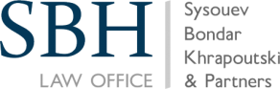
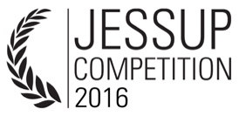
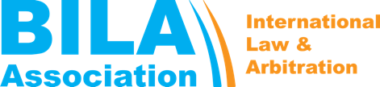
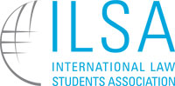

BELARUSIAN NATIONAL SUPPLEMENT
The 2016 Philip C. Jessup International Law Moot Court Competition
Belarusian National Supplement to the Official Rules of the 2016 Philip C. Jessup International Law Moot Court Competition has been prepared by the Belarusian National Administrator and approved by the Executive Director of the International Law Students Association (ILSA). The Belarusian National Rounds of Jessup Competition are administered by International Law & Arbitration Association (BILA).
Supplement to Off. Rule 1.4: Administrators
- BILA is an official Administrator of the Belarusian National Rounds and is approved by the ILSA Executive Director.
- Any Member of BILA Staff who wishes to serve as a Team Member, Team Advisor or a Judge, should inform the National Administrator as soon as possible.
- The National Administrator may not serve as Team Advisor or in any other way assist a Team. Nevertheless, the Administrator may organise events and publish materials, which provide Teams with general information about ILSA and the Jessup Competition.
Supplement to Off. Rule 2.15: Use of Opposing Team's Memorials and Arguments
The Teams will receive the Memorials of their opponents at least seven (7) days prior to the first day of the Belarusian National Rounds. The Memorials will be sent to the email indicated during the Team's registration at www.ilsa.org.
Supplement to Off. Rule 2.9: Assistance from Team Advisors
The “general commentary on the quality of the Team’s legal and factual arguments” that Team Advisors may provide should not include the correction of errors, alteration and commentaries on specific factual or legal ommissions. Such commentaries are considered as Outside Assistance to Teams under Official Rule 2.8.
Supplement to Off. Rule 6.1: Submission of Memorials
The e-mail address for the Submission of Teams Memorials to the Belarusian National Administrator is contact@bila.by.
Supplement to Off. Rule 6.18: Three-Judge Panels at Qualifying Competitions
If six (6) and more teams compete in the Preliminary Rounds of the Belarusian National Rounds, the Championship Round is held. In order to ensure the highest degree of impartiality and objectivity of the Championship Round, the panel is composed of five (5) judges. The lowest and the highest overall score of two (2) of the five (5) judges will not be taken into account by the National Administrator.
Example: The overall scores for Round are the following: Judge 1 – 259, Judge 2 – 200, Judge 3 – 387, Judge 4 – 334, Judge 5 – 400. The scores of Judge 2 (the lowest) and Judge 5 (the highest) will not be taken into account by National Administrator.
Supplement to Off. Rule 9.1: Representation
If one (1) Belarusian Team is allowed to take part in the International Rounds, the National Champion shall represent Belarus in the International Rounds. If two (2) Teams are permitted to participate in International Rounds, the National Champion and the National Runner-Up shall reprresent Belarus.
Supplement to Off. Rule 12.6: Other Awards

The Belarusian National Administrator at its own discretion may decide upon personal and team awards presented at Belarusian National Rounds.

National Administrator:
Andrey L. Kozik

Administrator’s Principal Staff:
Eugene Mintsevich
Maksim Holub
Vasili Pavlov

